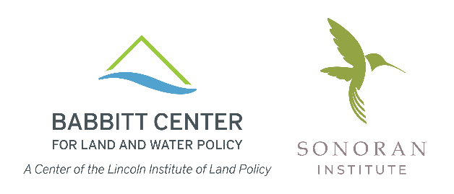

GROWING WATER SMART WORKSHOP – TEAM FORM
Alamosa, Colorado | June 8-10, 2022

Each Team Lead should submit the following information to
growingwatersmart@sonoraninstitute.org by April 22, 2022.

1. Workshop Team Members: Please secure agreement to participate from 5-8 team members and list them in this table.
Teams include those who can offer background, expertise, or passion regarding the area’s long-range community plans, land use codes, and development review processes; management of water resources; ecosystem resilience; and economic development. Members could be elected and appointed officials, land use planners, public works and other water resource managers, economic development managers, and local non-profit and community taskforce representatives.

 | Name | Title | Organization | Email Address
1
2
3
4
5
6
7
8

Please provide us with a brief overview of your perspective on the questions below. This information helps us tailor the workshop to the needs of each team.

2. Water Challenges: Describe the primary water challenges facing your team. How well do decision-makers and community members understand these challenges?

3. Land Use and Water Connection: To what extent do your area’s plans, policies, and programs currently address your water challenges?

4. Cooperation and Collaboration: What is the extent of cooperation or collaboration among the entities responsible for water planning and land use planning on your team? What is working and what could be improved?

5. Desired Outcomes: What would your team like to emerge from the workshop with?

Thank you!

